|  |  |  |  |
| --- | --- | --- | --- |
| Question | Q1 | Q2 | Q3 |
| Marks | 6 | 6 | 8 |
| Total | 20 | | |

**Full Name (as in course registration): Apar Garg**

**Date: 30/09/2021**

**Course:** **Spatial Reasoning from Sensor Data**

**Question 1.** For each question, select the **single** most appropriate answer, and **provide your justification** (no longer than two sentences).

a). Which of the followings is the **most** significant drawback of *bag of words* (BOW) models?

|  |  |
| --- | --- |
| 1. They don't capture spatial layout information of the image. | 1. They are only suitable for image classification. |
| 1. Creating BOW features is time-consuming. | 1. They require a huge dataset of images to build BOW models. |

Option A is correct.

BOW is a histogram-based technique. Hence, it captures only global information of the image. Finer/local details are lost.

b). What is the *scale-invariant feature transform* (SIFT) descriptor **least** robust against?

|  |  |
| --- | --- |
| 1. Global illumination change (e.g., brighter or darker) | 1. Rotation (e.g., rotate clockwise or counter clockwise) |
| 1. Scaling (e.g., zoom in or zoom out) | 1. Occlusion (e.g., occluded car plate due to another car) |

Option D is correct.

SIFT is robust to minor occlusions/noise only.

It is invariant to scaling since we define multiple scales at beginning. It is invariant to rotation since we assign orientation to pixels. It is invariant to illumination since we use the gradient orientation of surrounding pixels to make descriptors.

**Question 2.** You are engaged by a robotic vision company to develop a 3D vision based object retrieval system. Table 1 illustrates the input query and the top six retrieved results of the system. The retrieved results are displayed in the descending order that the most left result has the highest similarity score. Suppose that there are totally 3 sofa objects in the database. Evaluate the **average precision** (AP) performance for this system using this single query input. Show your calculations to justify your answer.

|  |  |  |  |  |  |  |
| --- | --- | --- | --- | --- | --- | --- |
| Input (sofa) | C:\Users\isstj\AppData\Local\Microsoft\Windows\INetCache\Content.MSO\4F4D5CD.tmp | | | | | |
| Top results | C:\Users\isstj\AppData\Local\Microsoft\Windows\INetCache\Content.MSO\CC7FF05F.tmp | C:\Users\isstj\AppData\Local\Microsoft\Windows\INetCache\Content.MSO\72683663.tmp | C:\Users\isstj\AppData\Local\Microsoft\Windows\INetCache\Content.MSO\18B938C5.tmp | C:\Users\isstj\AppData\Local\Microsoft\Windows\INetCache\Content.MSO\C518E169.tmp | C:\Users\isstj\AppData\Local\Microsoft\Windows\INetCache\Content.MSO\DEAC1B.tmp | C:\Users\isstj\AppData\Local\Microsoft\Windows\INetCache\Content.MSO\ABDAB7E1.tmp |
| Label | Sofa | Bed | Sofa | Chair | Toilet | Sofa |

Table 1. The input and top six retrieved results of the point cloud based object retrieval system.

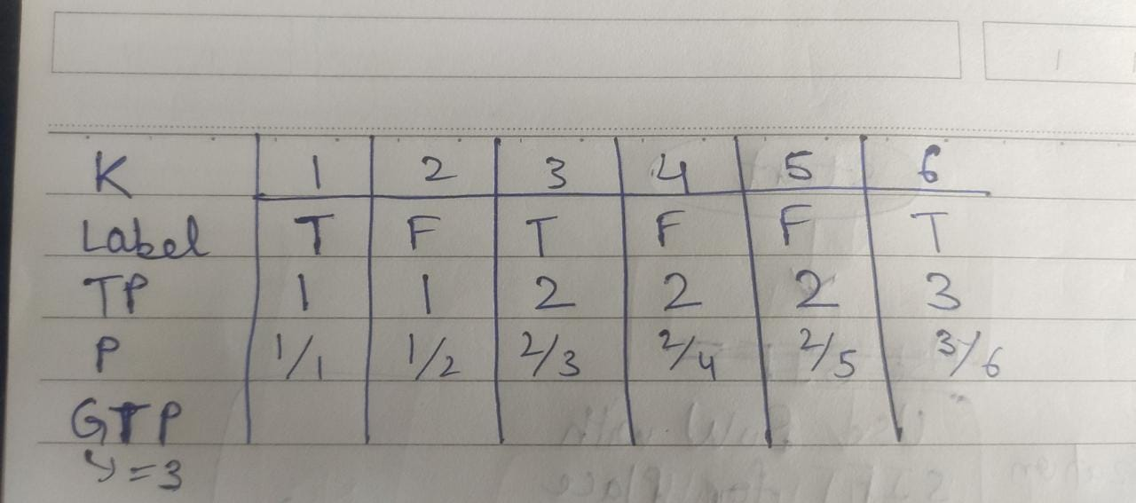

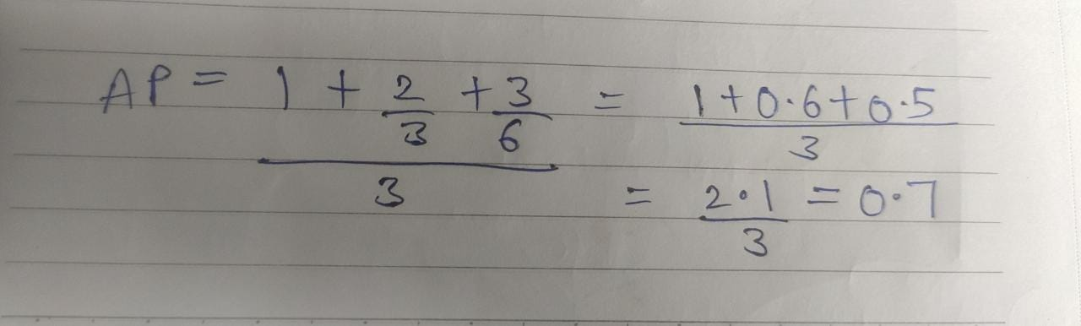

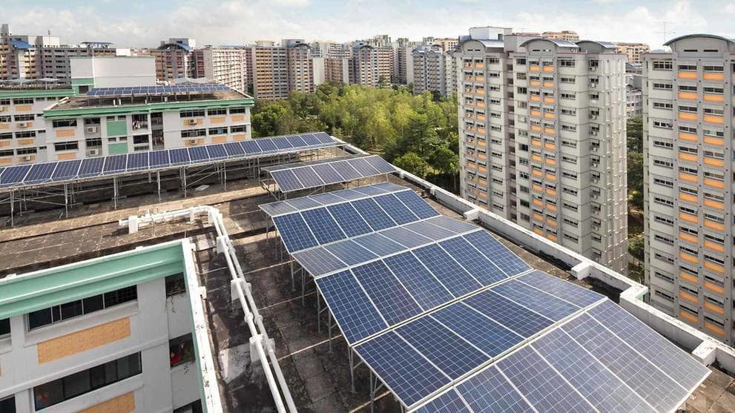**Question 3.** The *Housing Development Board* (HDB) in Singapore has planned that all future public housing blocks will be designed with solar-ready roofs. Inspecting these solar panels for possible defects can be a tedious process and even pose a safety risk to inspectors. It is potential to explore the *unmanned aerial vehicle* (UAV) inspection system using computer vision techniques. You are asked to **design an intelligent inspection system** that uses what you have learned in this class to perform inspection task for solar panels. The proposed system is required to have following two functionalities: (a) localization (inferring the location of the UAV), you can suggest what sensors should be used for this task; (b) automatic segmentation of the defect solar panel regions in the image captured by the camera mounted at the UAV. You can draw a flow chart to describe your proposed system.

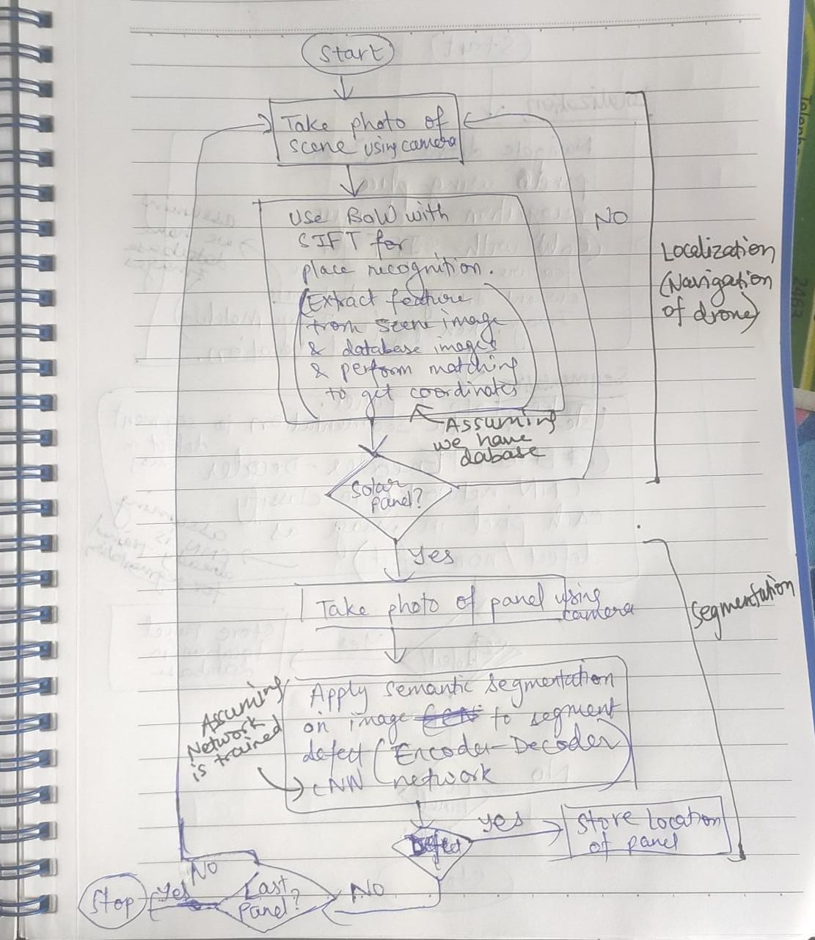

* You already mentioned ‘we assume a database’, so it would be good to separate it into an offline module and an online module clearly.

* The place recognition output should be a place (e.g., blk xxx, street xxx), not a solar panel, right?

The second part of your chart is ‘capture a photo of solar panel’. How can we ensure the image is focused on a solar panel without its complicated background? So I think it would be good to ‘detect’ solar panel first, followed by semantic segmentation on the detected solar panel bounding box.